EXPERIMENT:18

Create a Storage service using any Public Cloud Service Provider (Azure/GCP/AWS) and check the public accessibility of the stored file to demonstrate Storage as a Service.

STEP:1: CREATE A STORAGE ACCOUNT GO TO THE BASICS.

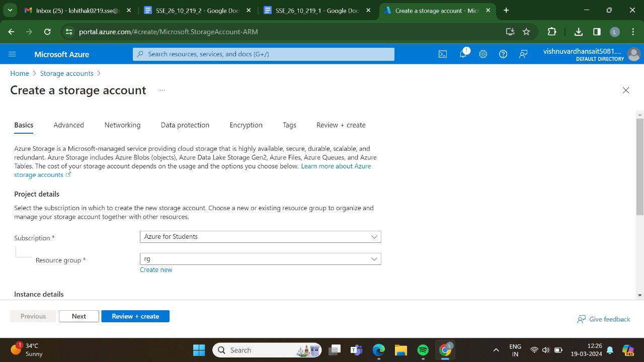

STEP:2:AND,THEN GO TO THE ADVANCED.

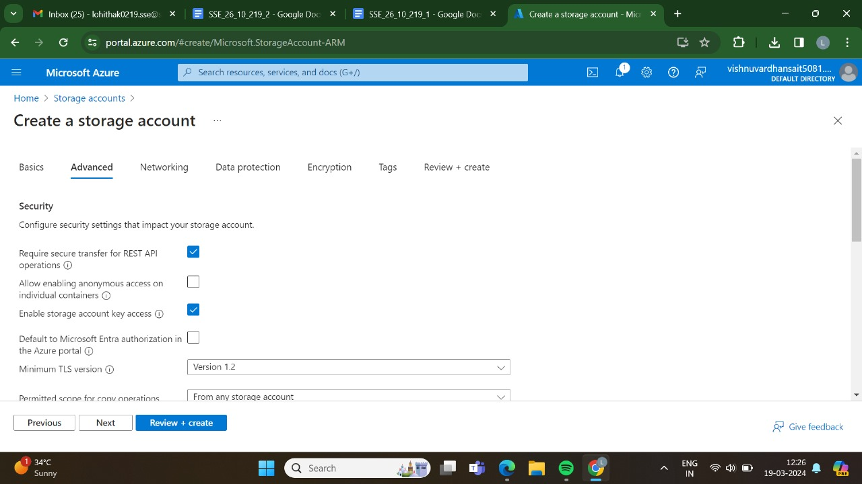

STEP:3:AND,THEN GO FOR THE NETWORKING.

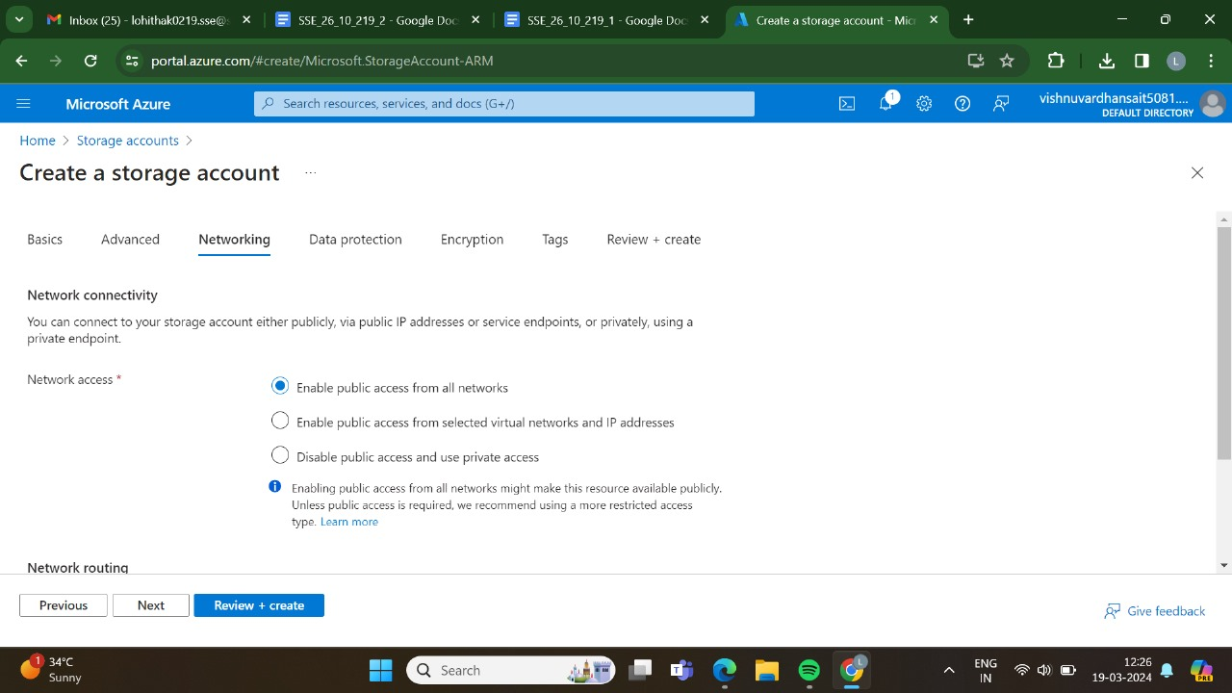

STEP:4:AND,THEN GO FOR THE DATA PROTECTION.

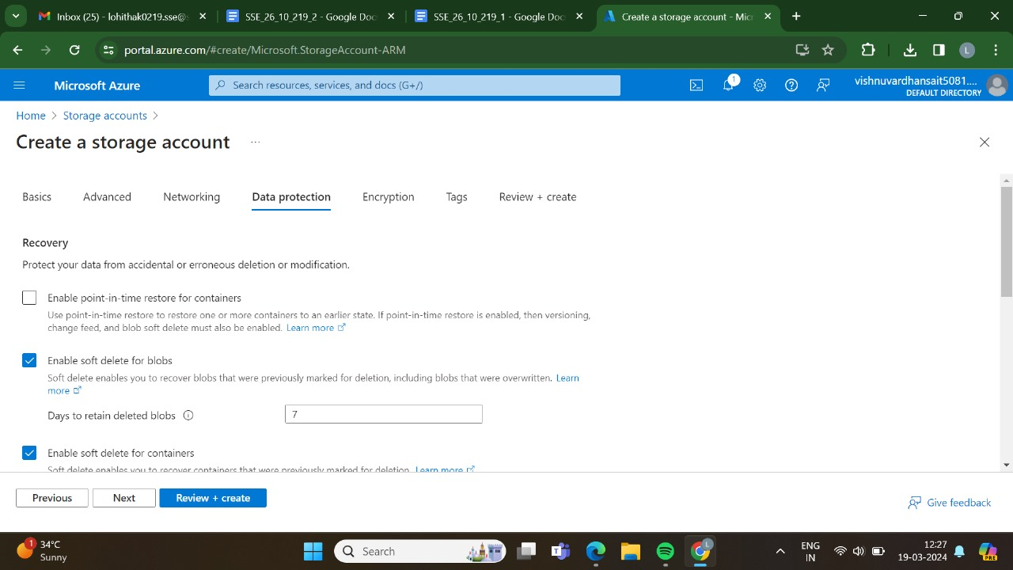

STEP:5:AND,THEN GO FOR THE ENCRYTION.

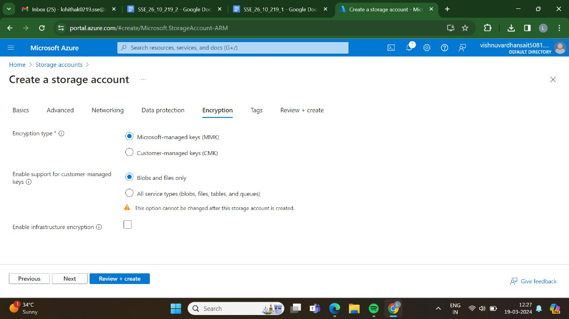

STEP:6:AND,THEN GO FOR THE TAGS.

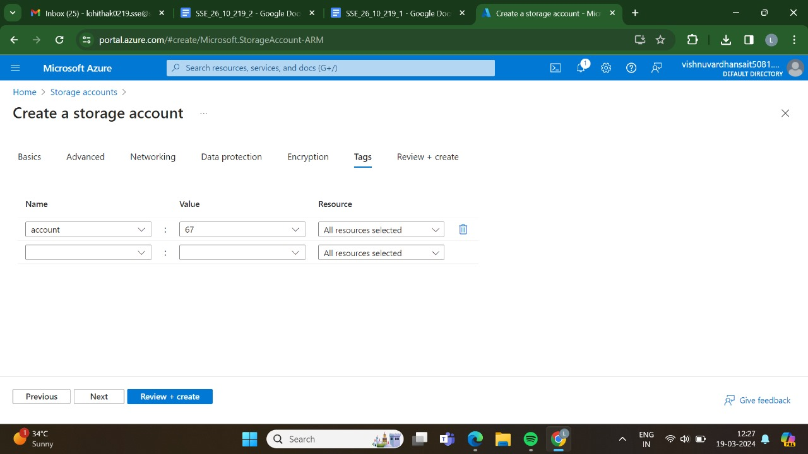

STEP:7:AND AT LAST GO FOR THE REVIEW + CREATE ,AND CLICK CREATE.

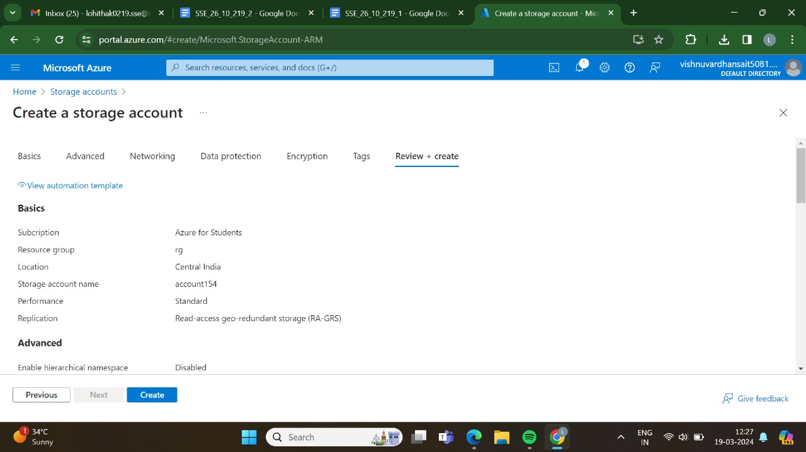

STEP:8:DEPLOYMENT IS IN PROGRESS.

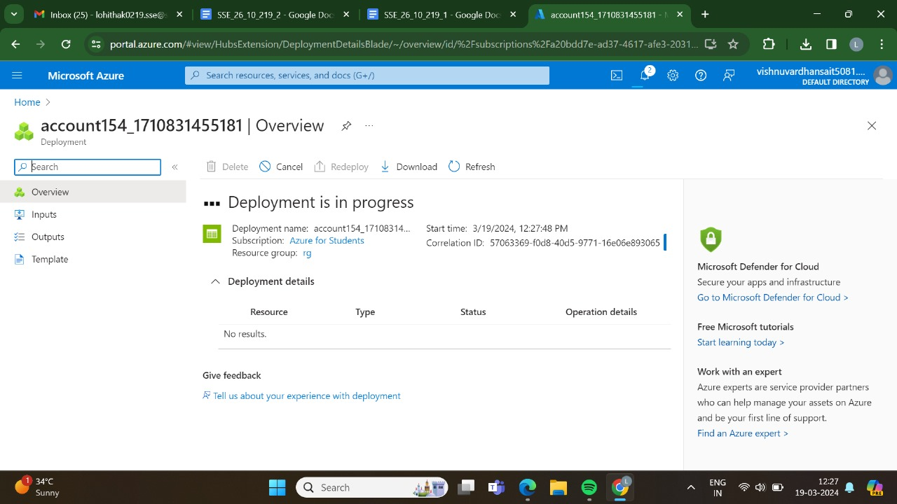

STEP:9:DEPLOYMENT HAS BEEN DONE SUCCESSFULLY.

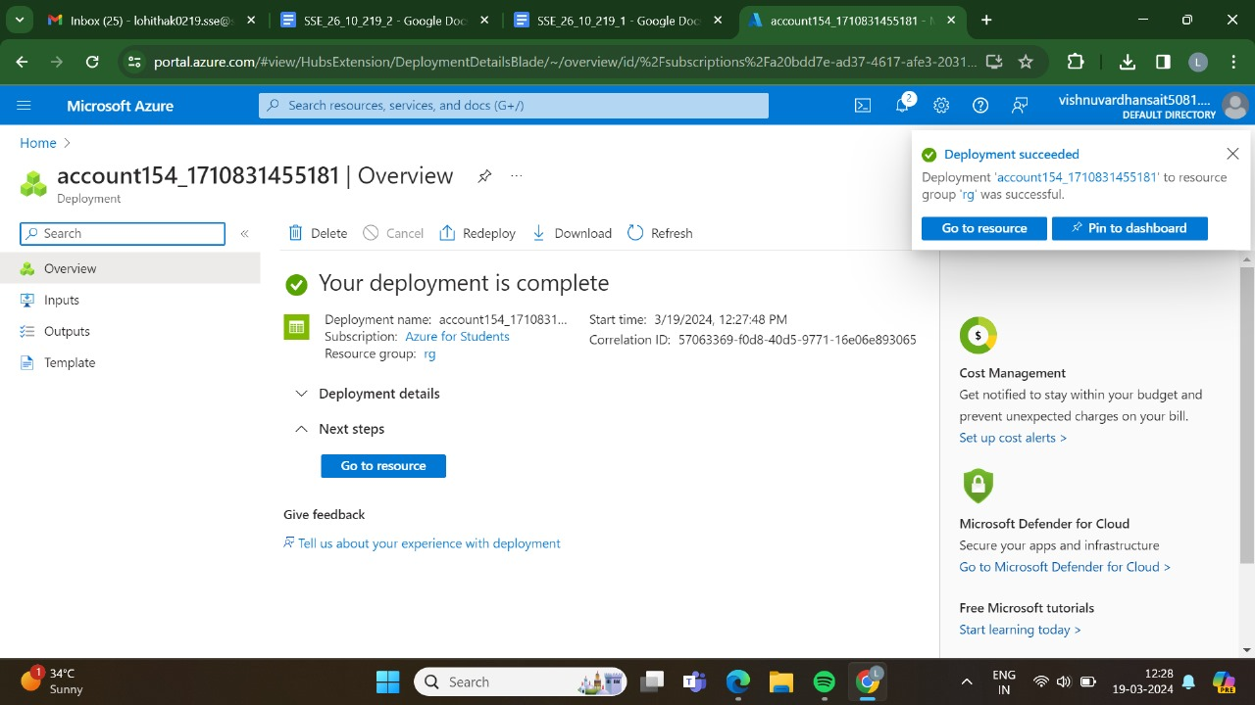

STEP:10:AND THEN GO FOR THE STORAGE BROWNSER.

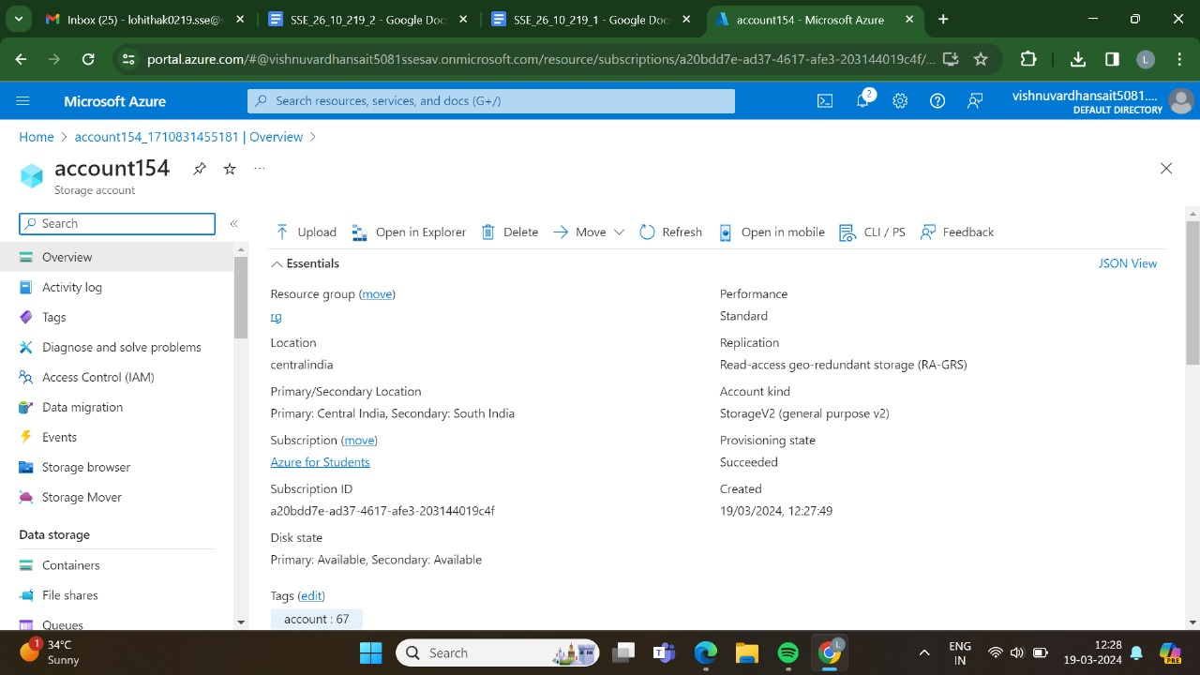

STEP:11: AND THEN GO TO THE FILE SHARES.

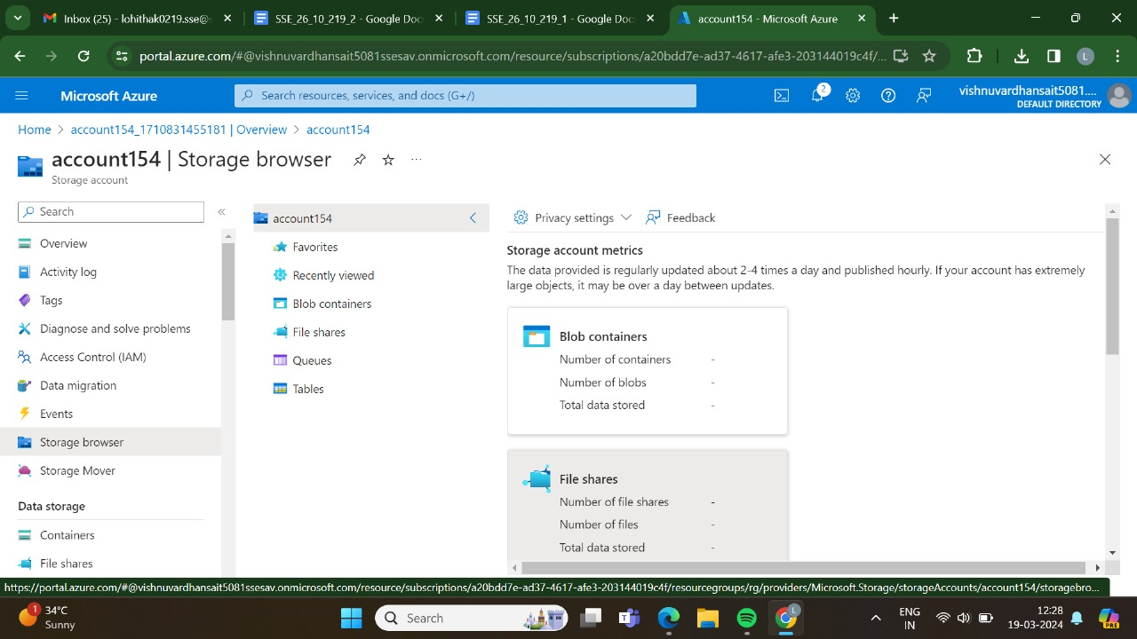

STEP:12: AND THEN CREATE A NEW FILE SHARE.

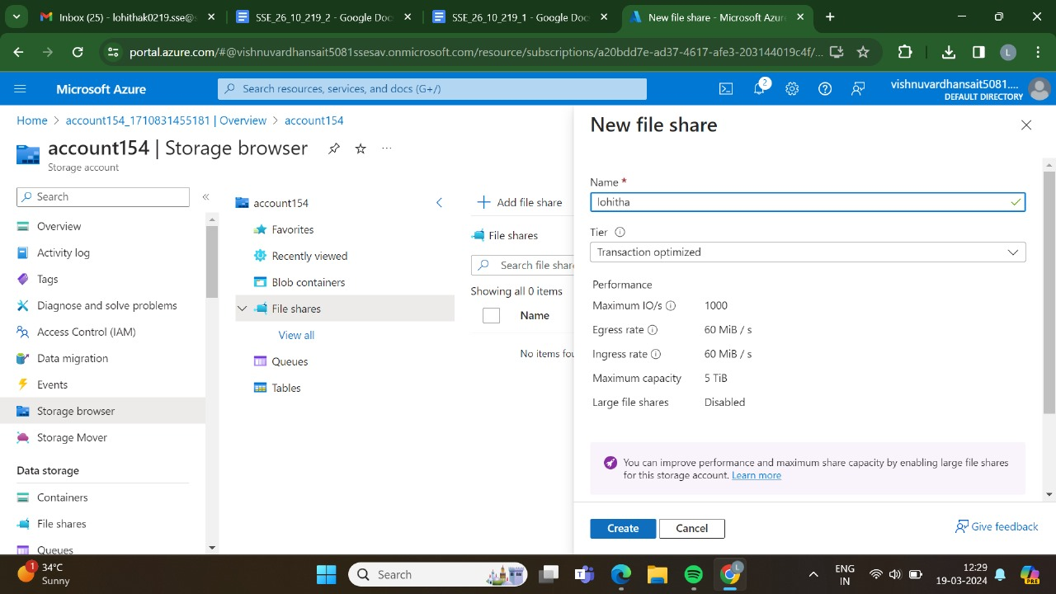

STEP:13:HAS BEEN DONE SUCCESSFULLY.

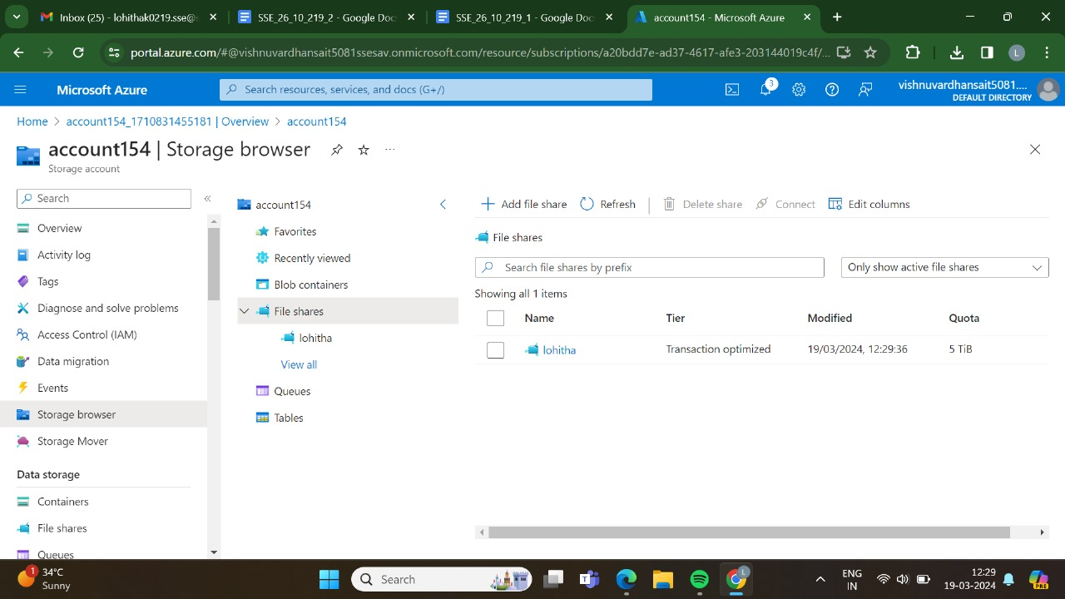

STEP:14: AND THEN GO AND UPLOAD THE FILES.

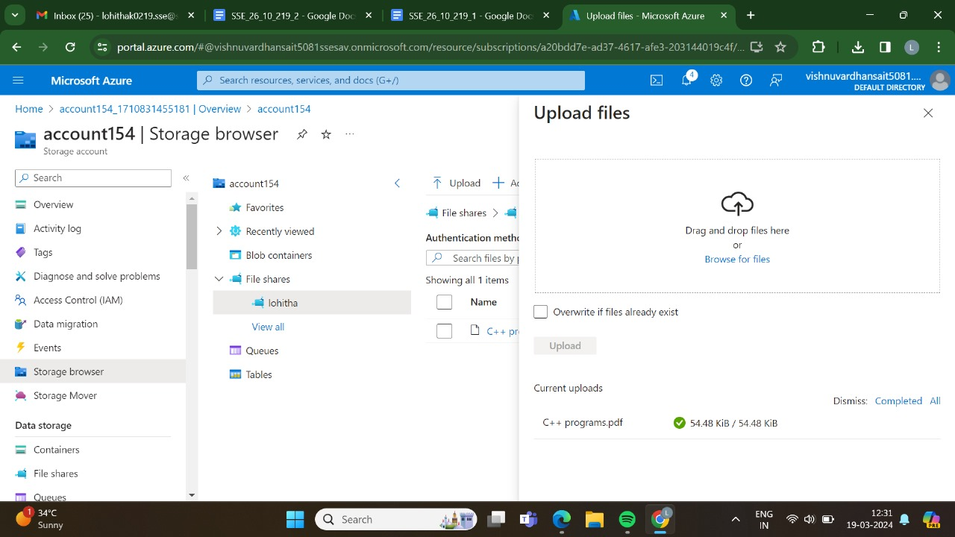

STEP:15:AT LAST THE FILE HAS BEEN UPLOADED SUCCESSFULLY.

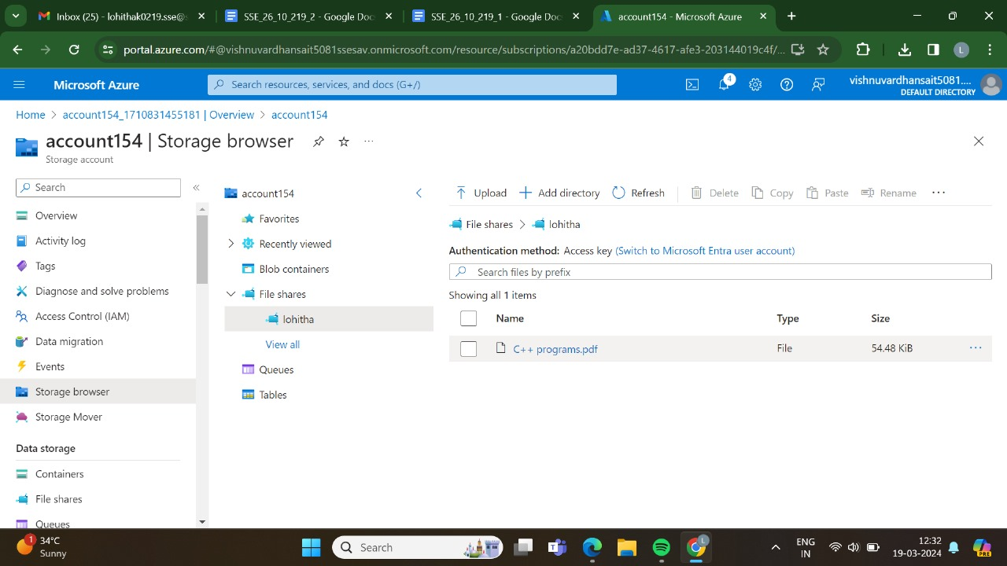

RESULT:THUS,THE PROGRAM HAS BEEN EXCEUTED SUCCESSFULLY.